________________________________________________________________________
CMHC Annual Program Report
Academic Year 2024–2025

Welcome to the 2024–2025 Annual Report for the Clinical Mental Health Counseling (CMHC) Program at D’Youville University. This report offers an overview of the program’s continued growth and sustained excellence as it advances through a period of intentional development and refinement. The CMHC program is committed to preparing compassionate, skilled, and ethical counseling professionals through rigorous academic training and meaningful applied learning experiences.
Throughout the 2024–2025 academic year, the program demonstrated strong performance across both ground and online modalities, meeting and often exceeding institutional and CACREP-aligned standards. Data drawn from Student Satisfaction Surveys (SSS) and Key Performance Indicators (KPIs) reveal steady progress in instructional quality, student engagement, and measurable learning outcomes. Both core and adjunct faculty continued to perform at equivalently high levels, underscoring the program’s success in fostering consistency, mentoring, and instructional equity across all teaching roles.
This report is intended to provide stakeholders, accreditors, and institutional partners with a clear, evidence-based account of the program’s achievements and areas for ongoing improvement. Overall, the CMHC program exceeded its aggregate 85% benchmark target across nearly all outcome areas, with the most notable performance gains observed between the Fall 2024 and Summer 2025 cohorts—reflecting a program that is thriving, responsive, and steadily evolving.
Demographics
Number of Students Currently Enrolled (FT & PT) | 91
Fall 2024 (initial starting cohort): | 14 (10 online, 4 hybrid)
Summer 2025 (second cohort) | 80 (mostly driven by NYS CPT Grand funding 69 online, 11 hybrid)
Geographical Indicators | Greater Buffalo Area: 65  New York City Area: 5  Remaining Areas within New York: 15  Outside NYS: Canada: 1  Colorado: 1  North Carolina: 1  Rhode Island: 1
Graduation Rates: | Initial cohort expected to graduate in August 2026
Licensure Exam Pass Rates: | Initial cohort expected to take their exams in 2027

Core Faculty: Dr. Margie McCarty, EdD, LMHC, ACS, Clinical Director, Associate Professor
Dr. Helena Boersma, EdD, LMHC-D, NCC, Clinical Director, Associate Professor
Dr. Marla Britton, EdD, LMHC-D, NCC, ACS, Clinical Assistant Professor
Dr. Aaliyah El-Amin-Turner, EdD, LMHC, NCC, Clinical Assistant Professor

Adjunct Faculty: Megan Sconiers, Ashley Belles, Chad Pautler, Richard Pierce, Raelyn Legg, Jenifer Willson, Erin McHugh, Margery Stanton, Vondolyn Lane, Erik Panna.

Student Feedback from Course Assessments

Hybrid Course Overview
- Mean faculty ratings across course instruction ranged 4.7–5.0 (out of 5.0) for the academic year.
- Both core and adjunct faculty maintained exceptional parity in teaching effectiveness, fairness, and organization.
- Students praised clarity, professional support, and course organization, while recommending minor refinements in early-term material access.
- The integration of applied learning techniques—case studies, simulated counseling sessions, and live feedback—significantly improved clinical readiness.

Online Course Overview
  - Average faculty scores across course instruction for Winter 2024–Summer 2025 ranged 4.6–4.9 (out of 5.0)
  - Core faculty maintained near-perfect averages (4.7–4.9).
  - Adjunct faculty improved from 4.0 in Fall 2024 to 4.6 in Summer 2025, achieving full instructional parity.
  - Students valued faculty visibility, video-based updates, and engagement, while recommending more standardized rubrics and synchronous learning opportunities.
Overall, student satisfaction data show remarkable consistency and alignment between modalities. The CMHC program demonstrates a mature instructional model with minimal variance between instructors and strong student trust in faculty quality.

Key Performance Indicators (KPI) Outcomes
Key Performance Indicators (KPIs) are measurable data points used to continuously and systematically assesses how students individually demonstrate progress toward, and mastery of, the knowledge, skills, and professional dispositions required of its graduates. CMHC has 50 academic KPIs and the 2024-2025 analysis is below.
Aggregate Performance Overview
- The program sets an 85% benchmark for KPIs to ensure mastery of core competencies. For the first year of the program, performance showed positive trends, but several KPIs did not meet the benchmark, which were primarily due to the structure of the rubrics not capturing the proper KPI assessment components.
- Faculty revised assessment rubrics to focus on criteria directly aligned with KPIs, leading to improved outcomes in subsequent course offerings.

Comparative Analysis of Online vs. Hybrid Student Performance
- Online students met or exceeded the benchmark for most KPIs, while hybrid students achieved 100% on all reported KPIs.
- Online performance varied, with some KPIs falling below the benchmark, and the majority meeting the KPI requirement.

Improvements to Assessment Processes
- The assessment process revealed that some rubric criteria did not directly measure the intended skills, leading to misleading KPI results. CMHC has reviewed all rubrics in all courses, not just those associated with KPI measurements, to improve accuracy in performance assessment for the intended learning measurements of the assignment.
- The Program Director was designated as a co-teacher for better access to assessment materials, and assignment alignments with CACREP Standards and KPIs were made transparent to faculty and students.
This comprehensive approach aims to enhance student learning outcomes and maintain alignment with CACREP standards while addressing areas needing improvement. Below are the KPI outcomes for individual KPIs and measurements.

Aggregate data for all assessment points collected for 2024-2025 are outlined below. The legend: green=met KPI, yellow=met KPI but cautiously, red=didn’t meet KPI. Overall, the data reflects most KPIs were met, and where they weren’t, additional explanation is offered.
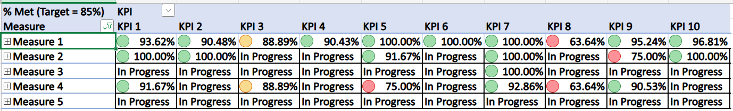
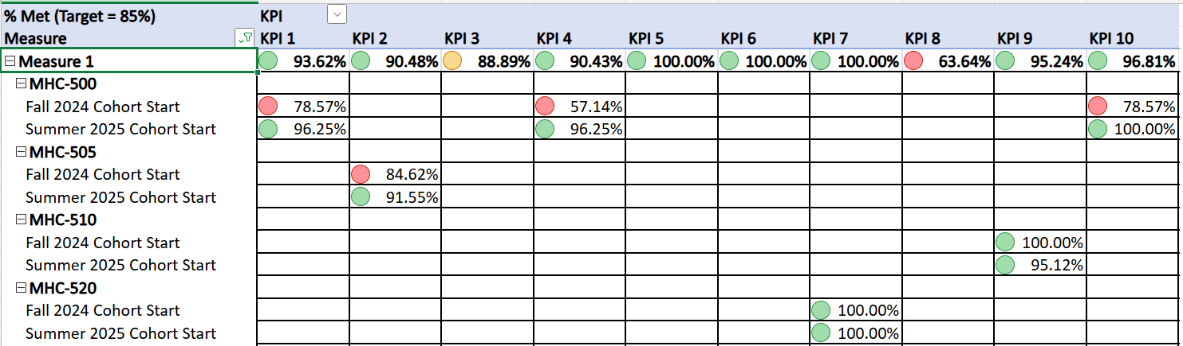
When exploring missed KPI, we learned, for example, that KPI1, Measure 1 in MHC-500, that had a 78.57% result was due to two factors. One, the actual measure for the KPI was to measure competency with an assignment that included a component on ethics. It turns out the rubric properly captured this information that demonstrated the student’s competency with the material. However, the student missed points for other non-KPI assessing reasons such as using proper APA formatting on the paper. As a result, the overall assignment grade was lower and didn’t accurately reflect if the KPI had been met or not. After review we were able to assess that the KPI was fully met and adjusted the rubric to ensure it only pulled data that assessed directly for the competency. You will see in the trending data that the next time the course was taught, the KPI was comfortably met.
CMHC was able to see some areas that needed attention and gave the needed attention, which resulted in improvements in the KPI outcome the next time the course was taught. Chart below highlights those KPIs where we begin to see trends.
KPI | Fall 2024 Cohort Start | Summer 2025 Cohort Start | Change | Trend
KPI 1 | 78.6% | 96.3% | +0.177 | Significant Improvement
KPI 4 | 57.1% | 96.3% | +0.392 | Major Improvement
KPI 10 | 78.6% | 100% | +0.214 | Full Achievement

All measurable KPIs improved between the Fall 2024 and Summer 2025 cohorts. Every indicator exceeded the 85% target threshold by the end of the year. KPI 4, representing a key student outcome measure, showed the largest gain (+39%), indicating targeted curriculum or instructional interventions were highly effective. These improvements reflect enhanced consistency in student learning outcomes, clearer course structure, and improved faculty alignment.

Curriculum Updates
Via the Student Satisfaction Survey which means multiple components of a students course experience (curriculum, instruction, content, and more), we learned areas where CMHC could consider changes. CMHC organized some of themes from the student feedback that was discussed in its Annual Curriculum Program meeting in Fall 2025. Here are some of the highlights that were discussed with the corresponding outcomes.
- Technology and Course Consistency
- Adopted standardized Canvas templates and course design protocols.
  - Response: CMHC will continue to work with Online Learning Program, now called Institute for Teaching Innovation, to ensure a smoother vibe between courses.
- Implemented pre-term technology audits to ensure readiness.
  - Response: Encourage students and instructors to review all components of their canvas courses before the course begins to ensure all tech is working.

- Assessment Calibration
- Revised grading rubrics and introduced peer review among faculty.
  - Response: Faculty noted that there were some inconsistencies with rubric formatting and usefulness in assessing student learning. Each course assignment and its corresponding rubric was reviewed to improve the learning experience.

- Faculty Development
  - Expanded mentoring and adjunct orientation processes.
    - Response: CMHC core faculty agreed that a bit more time and attention could be dedicated to onboarding new adjunct faculty members, ensuring their level of competency with course assignments, apps used in the courses, tools embedded in canvas, program processes, grading, and consistency with delivering other instructional components.

- Applied Learning Enhancements
- Integrated simulation-based exercises, case analyses, and live feedback models.
  - Response: CMHC has built into its second year courses more experiential exercises, so we’re on the right track. CMHC recognized it may be able to bring in some of these experiences sooner and considered options.

- Quality of Instruction
  - Over and over again, students commented on the positive interactions they had with faculty instructors during their learning experiences, and when there was a noted concern, students noted they received the feedback on how to improve the communication for the next time. Response: We smiled and accepted the new program was on the right track!

Learning Trends and Continuous Improvement
Emerging Strengths
- High instructional consistency across modalities.
- Clear evidence of adjunct–core parity by end of AY 2024–2025.
- Data-driven curriculum adjustments linked to measurable student gains.
Ongoing Priorities
- Continue refining rubric alignment and grading transparency.
- Expand optional synchronous learning opportunities within the online courses.
- Maintain early-semester readiness through faculty mentorship.
- Continue post-semester individual student check-ins to listen to feedback and how to offer needed support
- Monitor KPI outcomes to ensure sustained improvement.
- Hire additional core faculty members to meet the expanding program needs.

Clinical Placement Experiences
Eleven (11) CMHC students started Practicum in Fall, 2025. One student located in Colorado is completing both Practicum and Internship at an outpatient substance abuse / mental health counseling facility. Another student in North Carolina is completing Practicum at an outpatient agency. Two students located in Rochester, NY, are placed at the same domestic violence center that offers mental health counseling. One student in the NYC area secured a Practicum and Internship at an outpatient behavioral healthcare agency, and another student in the NYC area is completing Practicum at a mental health agency that pushes into a K-6 school. The remaining five students are placed at behavioral healthcare agencies in the greater Buffalo area for Practicum and Internship.
New Community Counseling Center
A new six-room Community Counseling Training Center was established in the DAC building to enhance student practicum training experiences and provide students with hands-on clinical experience prior to internship placement in the field. The center offers a structured environment where CMHC students work with both campus and community members to support their mental health needs. In addition to individual counseling sessions, the facility facilitates group counseling opportunities that address a broad range of clinical concerns, fostering skill development and community engagement.
Community Engagement
Awarded grant by the NYS Office of General Services on behalf of the NYS Office of Cannabis Management for Community Reinvestment Program Grant. This grant is $100,000.00 to be reinvested into the community. D’Youville’s grant objectives, which are implemented by Vondolyn Lane, grant coordinator, and overseen by the CMHC program director are:
- Increase access to mental health resources for at-promise youth (age 16-24) in target zip codes of 14201, 14213, 14215, 14210, 14211, 14214, 14208, 14212, and 14207.
- Increase access to psychoeducational materials for at-promise young people to address anxiety and depression and promote independent living skills.
- Increase career guidance and counseling services for at-promise individuals ages 16-24.
- Provide information for parents, guardians, and families of at-promise young people.
Conclusion
The 2024–2025 academic year confirms that the CMHC program is meeting or exceeding expectations in all major performance domains. Faculty, both core and adjunct, deliver consistent, high-quality instruction supported by evidence-based curriculum design. Performance improvements between the Fall 2024 and Summer 2025 cohorts validate the program’s ongoing cycle of assessment, reflection, and adaptation. Our first cohort of students are currently in their field placement experiences and expected to graduate by August 2026.

